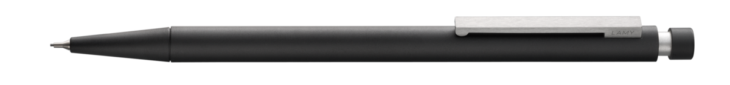

Lamy Scribble Mechanical Pencil

The Lamy Scribble Mechanical Pencil is a sleek and durable writing instrument designed for both sketching and writing. Its ergonomic shape and balanced weight ensure comfort, while the 0.7 mm lead provides precision. Perfect for professionals and enthusiasts alike, it’s a reliable tool that embodies Lamy’s commitment to design and quality